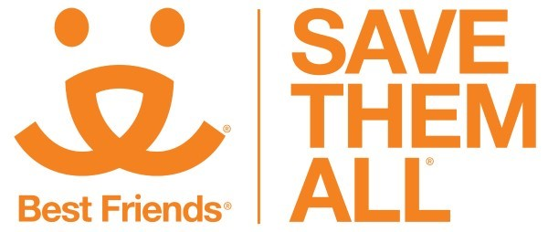

Foster Win Campaign
Sample Email copy

SUBJECT LINE: Go ahead. Keep that foster.

Dear FIRST NAME,

During these uncertain times, a lot of things seem to be changing. Toilet paper is more valuable than gold, productivity is measured by whether or not you’re wearing pants, and your pillowcase might become fabric for your next face mask. And now, when someone calls you a “foster fail,” you’re actually winning!

When you foster-fail, you’re deciding to keep that little snuggle monster you took home. Foster-failing means you and your pet failed to find anyone more perfect than each other. Foster-failing means love.

So, go ahead. Keep that dog or cat you volunteered to foster. Because in this world, failing isn’t bad. Failing is good. Failing is healthy. Failing is unconditional love for you and that furry, four-legged friend you can’t imagine your life without.

And if you have a foster-fail, ahem… that is, a foster-WIN you’d like to tell the world about, share your story on social media with the hashtag #fosterwin. We’d love to see how you and your pet are failing together.

Not ready to hold on to a foster pet just yet? Lots of animals still need a home in-between homes, and by continuing to foster you’re giving pets in need a second chance.

Thank you for fostering a homeless pet.

SIGNATURE

